EDUDOC RECOVERY SYSTEM

The Project Report submitted to the Bharathiar University in partial fulfillment of the Requiirements for the Award of the Degree of

MASTER OF SCIENCE IN COMPUTER SCIENCE

Submittedby
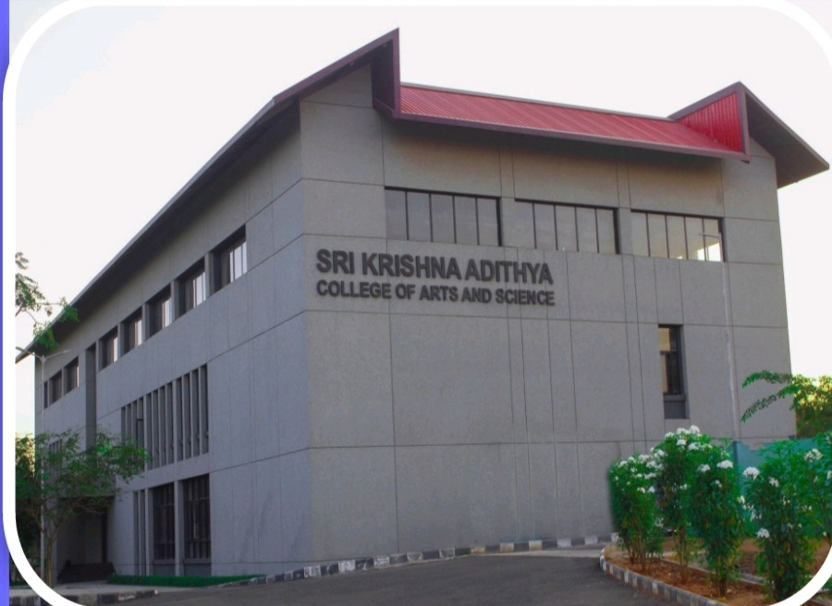

SANTHOSH B

(2432K0430)



Under the guidance of

Mr . M . ARUN.,MCA.,phd

Assistant Professor

DEPARTMENT OF COMPUTER SCIENCE


March 2026

